The sale of a main home is generally not a taxable event if:
- Residence was main home
- Taxpayer satisfies ownership and use tests
- Gain less than $250,000 ($500,000 MFJ)
- Taxpayer did not receive
Form 1099-S

Report the sale or exchange of your main home as a Capital Gain or Loss if:
- You can’t exclude all of your gain from income, or
- You received a Form 1099-S for the sale or exchange.

Generally, if you meet the following two tests, you can exclude up to $250,000 of gain. If both you and your spouse meet these tests and you file a joint return, you can exclude up to $500,000 of gain (but only one spouse needs to meet the ownership requirement in Test1)
- Test 1. During the 5-year period ending on the date you sold or exchanged your home, you owned it for 2 years or more (the ownership requirement) and lived in it as your main home for 2 years or more (the use requirement).
- Test 2. You haven’t excluded gain on the sale or exchange of another main home during the 2-year period ending on the date of the sale or exchange of your home.

If you have a gain that can’t be excluded, it is taxable.

Death of spouse.
- If you sell your home after your spouse dies (within 2 years after your spouse dies), and you have not remarried as of the sale date, you can count any time when your spouse owned the home as time you owned it, and any time when the home was your spouse’s residence as time when it was your residence. You can exclude up to $500,000 of gain if: just before your spouse's death, both spouses met the use requirement and at least one spouse met the ownership requirement of Test 1, and both spouses met Test 2.

Increases to basis. These include the following.
- Additions and other improvements that have a useful life of more than 1 year.
- Special assessments for local improvements.
- Amounts you spent after a casualty to re-store damaged property
See Pub 4012, page D-42 and Pub 523 for examples of improvements vs repairs

Use the following documents as references when completing a Sale of Home transaction:
. Pub 4012 – Page D-41 -D-43
. Pub 17 – Chapter 15 – Selling Your Home
. Pub 523 – Selling Your Home

To enter the sale of a main home as a gain, or there is a gain that is cancelled by the exclusion, enter “Sale of home” in the search box or toggle to the capital gains screen. Select the “Sale of Main Home Worksheet”. Complete as shown below. The information shown below is also in Pub 4012 pages D-41 and D-42.

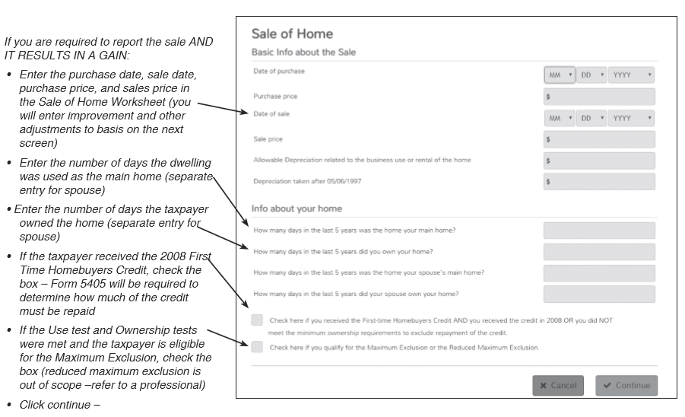

Complete the Adjustments Worksheet

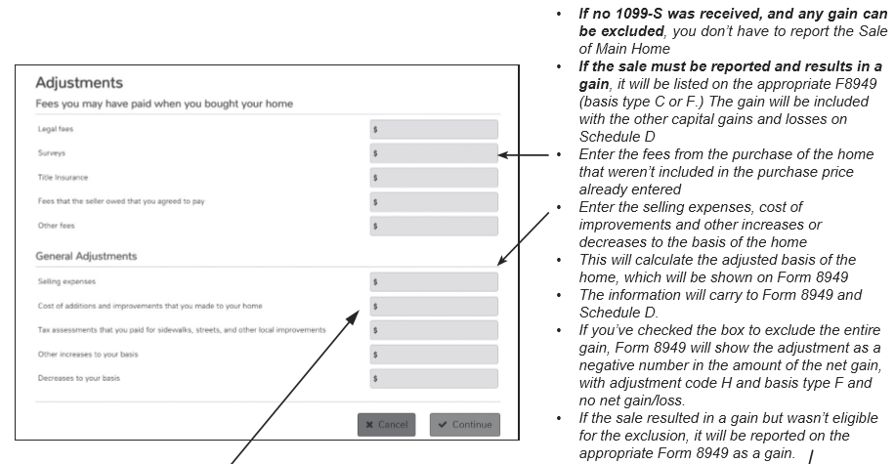

TSO will complete the required Form 8949 and if there is a gain, move the gain to Schedule D and the 1040 line 13.

Example

Automatically generated 8949 for Sale of Home with a gain and neither TP or spouse qualifies for the exclusion.

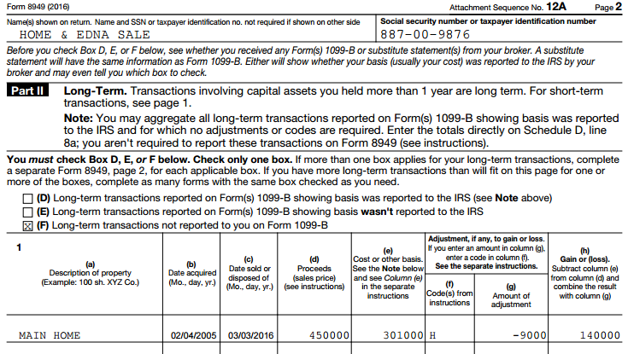

This amount goes to Schedule D & 1040 line 13
This amount is from the general adjustments portion of the worksheet

Automatically generated 8949 for Sale of Main Home with TP and SP who qualify for the exclusion.

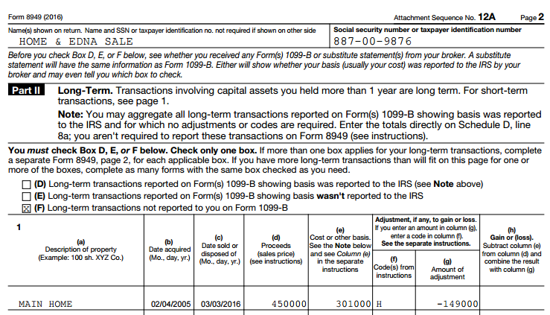

This amount includes amounts from the general adjustments portion of the worksheet plus any excluded amounts

.

If the sale is a loss but must be reported because Form 1099-S was received, follow the procedure below. This information is also located in Pub 4012, page D43.

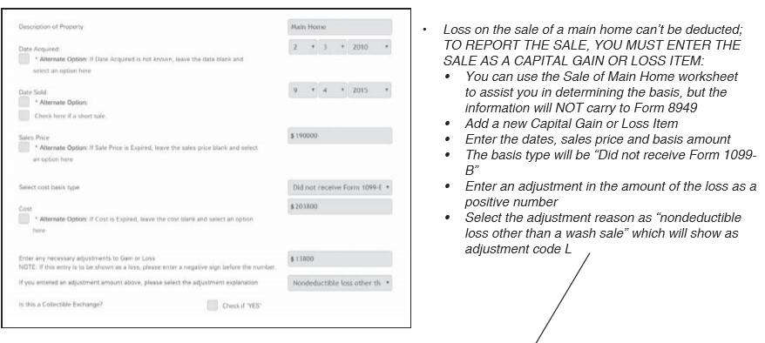

Example
Form 8949 after manually completing the capital gains transaction of a loss sales that must be reported because the TP received a 1099-S.

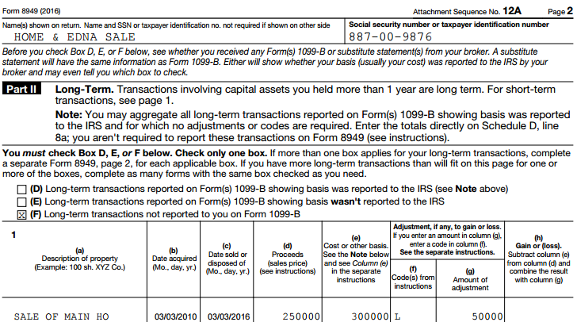
Nondeductible loss other than a Wash Sale

